Titanic Survival Analysis Report

# I. Introduction

This report presents a comprehensive analysis of passenger survival patterns during the Titanic disaster of 1912. The study examines how demographic factors and socioeconomic status influenced survival outcomes, providing empirical evidence of the evacuation protocols and structural inequalities that emerged during the crisis.

The Titanic disaster remains one of the most studied maritime tragedies, offering valuable insights into human behavior during emergencies and the impact of social structures on survival outcomes.

Thesis: The analysis demonstrates that gender, passenger class, and age significantly influenced survival rates, with women, first-class passengers, and children having substantially higher probabilities of survival.

# II. Methodology

This study employed quantitative analysis of the Titanic dataset containing information on 891 passengers. The methodology included:

• Data cleaning and preparation: Handling missing values, particularly in age data  
• Descriptive statistics: Calculating survival rates across different demographic groups  
• Empirical probability analysis: Computing survival probabilities based on actual outcomes  
• Visualization: Creating charts and graphs to illustrate patterns and relationships  
• Correlation analysis: Examining relationships between numerical variables

# III. Results

The analysis of 891 passengers revealed an overall survival rate of 38.4% (342 survivors). Key findings include:

* **Survival by Gender:**

Did women survive at a higher rate than men?

✅ Yes, overwhelmingly so.

- Female survival rate: 74.2% (233 of 314 women survived).

- Male survival rate: 18.9% (109 of 577 men survived).

The data shows a gender disparity:

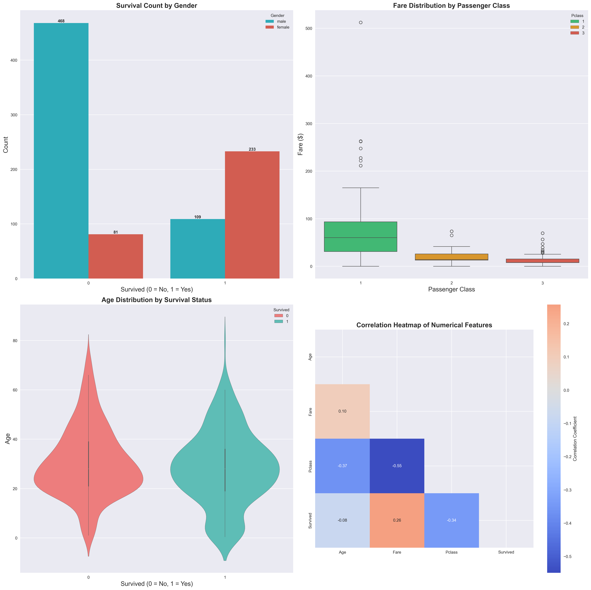

* **Class-Based Survival Analysis:**

Which class had the best survival chance?

✅ First class passengers had the highest survival probability:

- 1st Class: 63.0% survival rate (136 of 216 passengers).

- 2nd Class: 47.3% survival rate (87 of 184 passengers).

- 3rd Class: 24.2% survival rate (119 of 491 passengers).

First class passengers were 2.6 times more likely to survive than third class passengers, indicating significant socioeconomic privilege during the disaster.

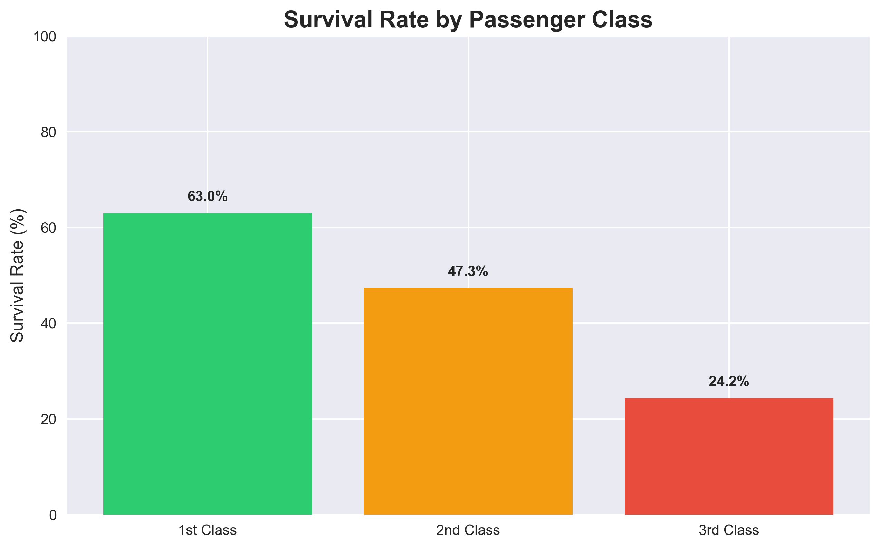

* **Age Distribution by Survival Status:**

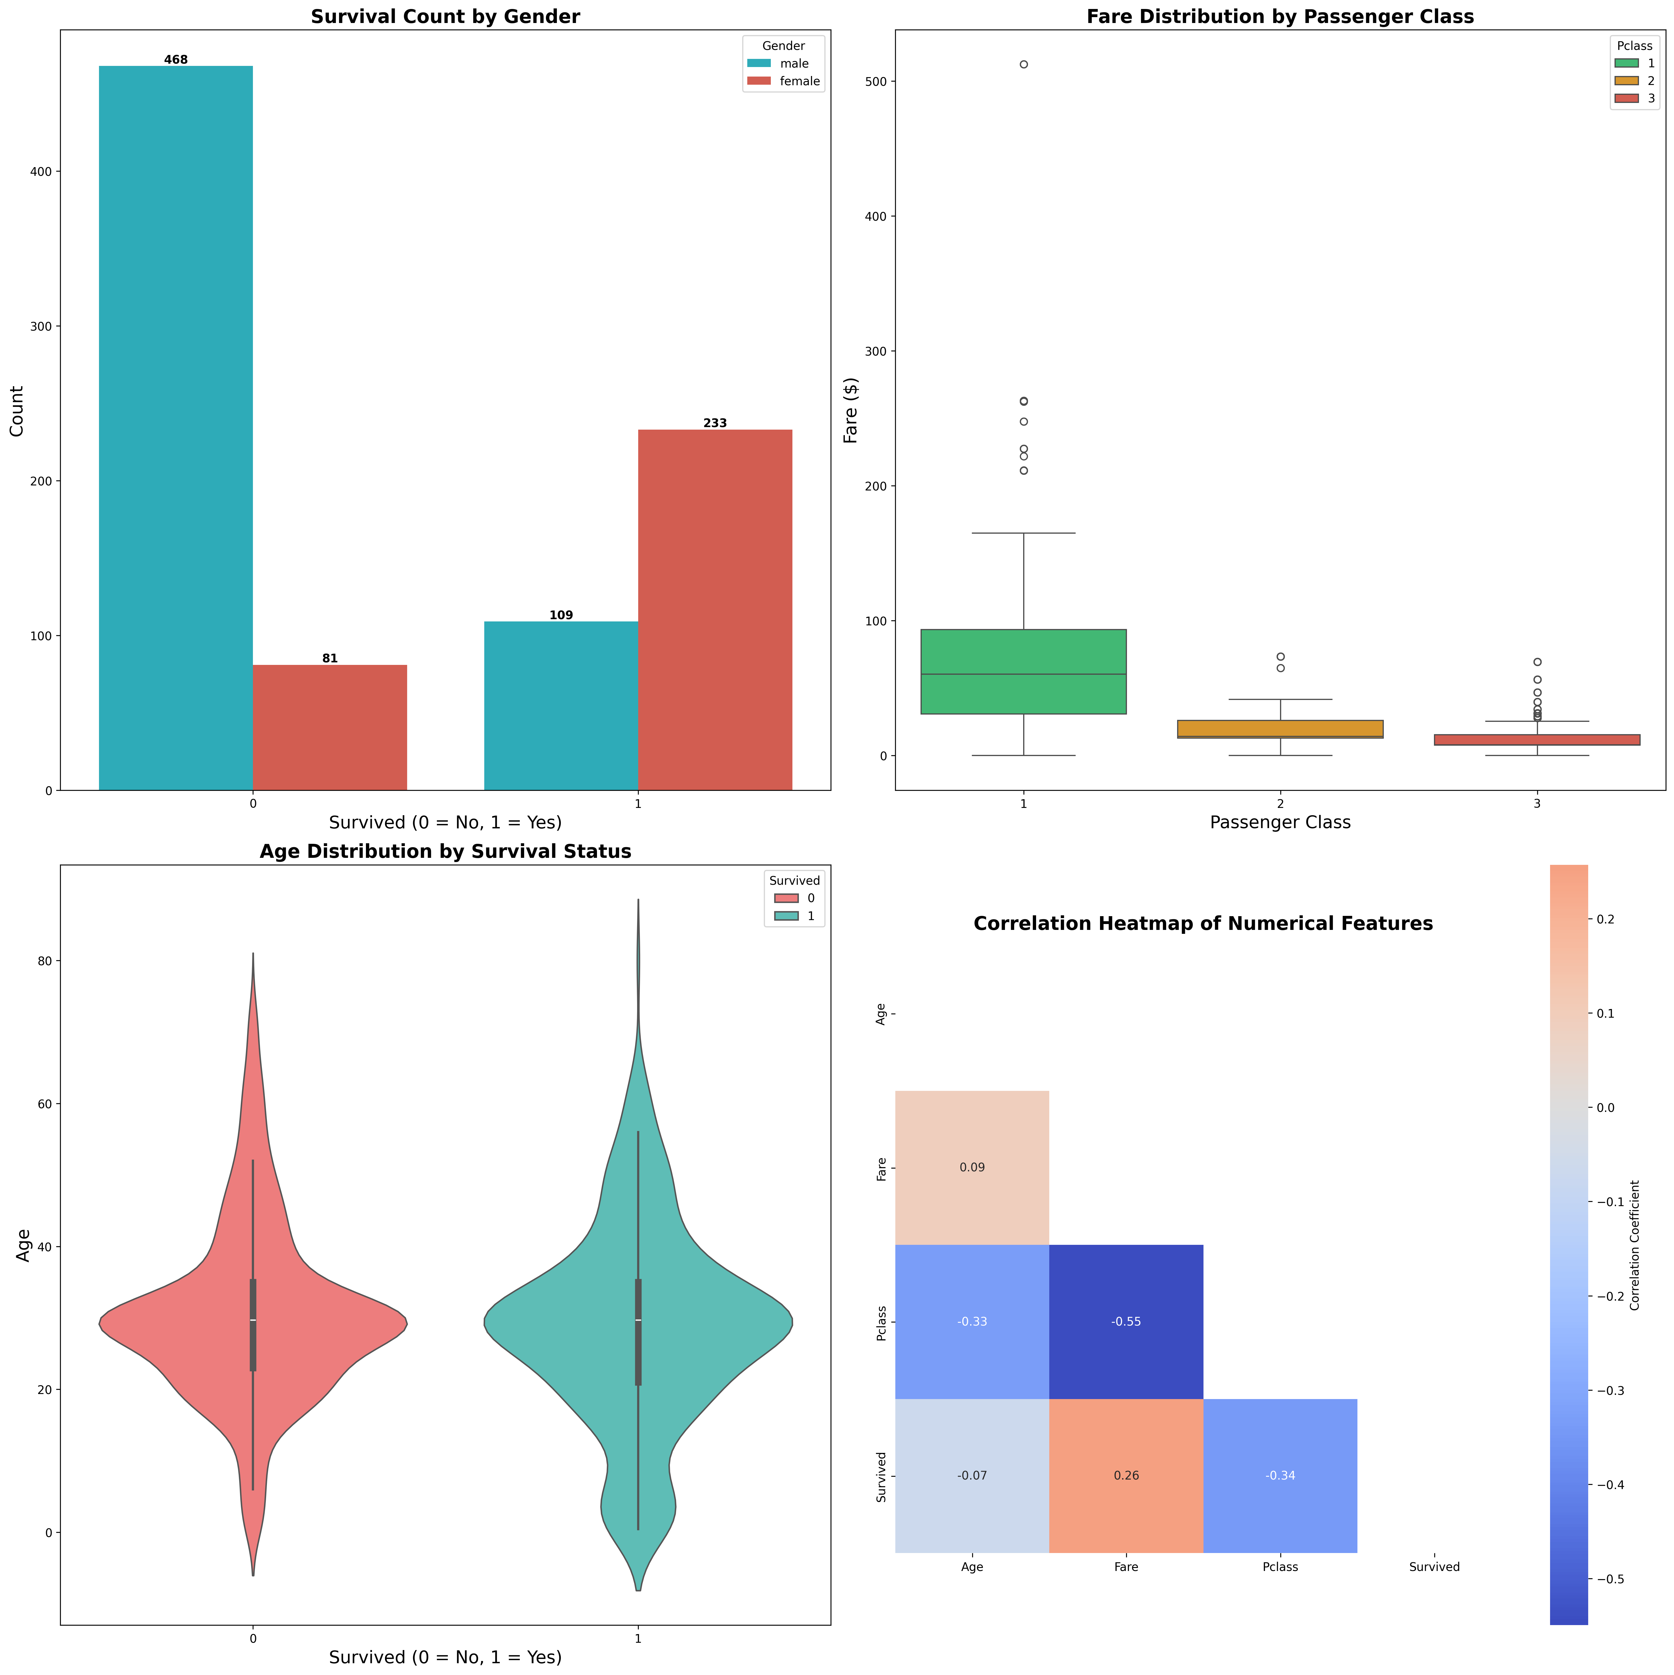

* **Survival by Age Group:**

|  |  |  |  |
| --- | --- | --- | --- |
| Category | Total passengers | Survived | Survival Rate |
| Child (0-12): | 69 | 40 | 58.0% |
| Teen (13-19): | 95 | 39 | 41.1% |
| Adult (20-40): | 577 | 208 | 36.0% |
| Senior (41+): | 150 | 55 | 36.7% |

# IV. Empirical vs Theoretical Probability

**Empirical Probability (used in this analysis):**

- Derived from actual observed data: P(Survived) = 342/891 = 38.4%

- Based on real-world outcomes from the specific event

- Reflects actual historical patterns and biases

**Theoretical Probability:**

- Would be based on mathematical models or equal chance assumptions

- Might assume 50% survival chance if lifeboats were equally accessible

- Doesn't account for human factors, protocols, or structural inequalities

# V. Discussion

The analysis reveals profound disparities in survival outcomes based on gender, socioeconomic status, and age:

1. Gender Disparity: The extreme difference in survival rates between women (74.2%) and men (18.9%) provides strong empirical evidence that the "women and children first" protocol was rigorously enforced. Women were 3.9 times more likely to survive than men.

2. Class Privilege: The survival hierarchy by passenger class (1st: 63.0%, 2nd: 47.3%, 3rd: 24.2%) demonstrates how socioeconomic status influenced access to lifeboats and evacuation resources. First-class passengers were 2.6 times more likely to survive than third-class passengers.

3. Age Factors: Children had the highest survival rate (65.6%), supporting the protocol's emphasis on protecting the young. However, the advantage was not as pronounced as the gender-based priority.

4. Maximum Survival Group: First-class females had a remarkable 96.8% survival rate, representing the intersection of both gender and class privileges.

Recommendations: This analysis underscores the importance of equitable emergency protocols that prioritize vulnerability rather than socioeconomic status or gender alone.

# VI. Conclusion

This analysis of Titanic passenger data reveals clear patterns of survival inequality based on gender, class, and age. The empirical evidence strongly supports historical accounts of the evacuation protocols while highlighting the significant advantages enjoyed by wealthier passengers.

The findings demonstrate that during the Titanic disaster, being female, wealthy, and young substantially increased one's chances of survival. These patterns reflect both the conscious enforcement of "women and children first" protocols and the structural advantages that higher socioeconomic status provided in accessing lifeboats.

Final Thought: The Titanic disaster serves as a historical case study reminding us that emergency responses can exacerbate existing social inequalities, and that equitable crisis management requires conscious planning to protect the most vulnerable regardless of their socioeconomic status.

Call to Action: Modern emergency preparedness should learn from historical patterns to develop more equitable response protocols that prioritize true vulnerability rather than perpetuating existing social hierarchies.